To run scenarios in parallel mode, then junit wont work. We need testng for that.

# Open pom and add this dependencies-

# Another plugin to be added-

# Slight changes in folder structure for testng-

Create a package called parallel in “src/test/java”.

And move the step def into it. settings will be as below.

Move the hooks also to parallel package.

Note-

Whatever feature files are present, they should be present under same package where step def is located.

runner files and step def needs to be under same package as per the cucumber documentation, so runner can pick the step def and app features correctly.

# Parallel folder created for features in src/test/resources-

We can give any name; not necessary the name should match the one with the step def.

# Three main folders-

Src/main/java – for page factory, driver factory, page class, utility, page class.

Src/test/java – step def and runner and hooks. All should be under same folder or package in this module.

Src/test/resources – a folder which will have all the app features.

Once all done, right click on project – maven – update project.

Note-

Testng will not be there.

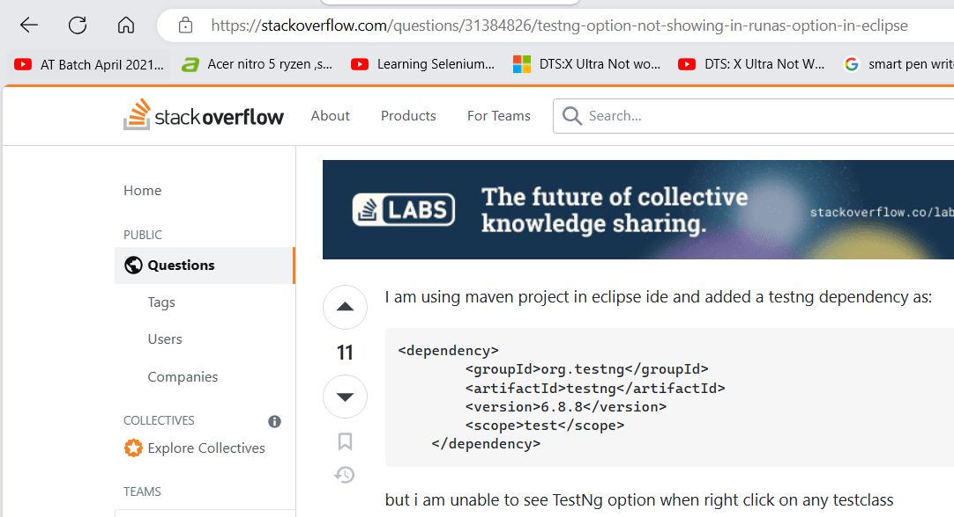



[TestNG option not showing in RunAs option in Eclipse - Stack Overflow](https://stackoverflow.com/questions/31384826/testng-option-not-showing-in-runas-option-in-eclipse)

Run as testng-

# You may get this exception when you run first time-

|  |
| --- |
| Exception in thread "main" java.lang.UnsupportedClassVersionError: org/testng/remote/RemoteTestNG has been compiled by a more recent version of the Java Runtime (class file version 55.0), this version of the Java Runtime only recognizes class file versions up to 52.0  at java.lang.ClassLoader.defineClass1(Native Method)  at java.lang.ClassLoader.defineClass(ClassLoader.java:763)  at java.security.SecureClassLoader.defineClass(SecureClassLoader.java:142)  at java.net.URLClassLoader.defineClass(URLClassLoader.java:468)  at java.net.URLClassLoader.access$100(URLClassLoader.java:74)  at java.net.URLClassLoader$1.run(URLClassLoader.java:369)  at java.net.URLClassLoader$1.run(URLClassLoader.java:363)  at java.security.AccessController.doPrivileged(Native Method)  at java.net.URLClassLoader.findClass(URLClassLoader.java:362)  at java.lang.ClassLoader.loadClass(ClassLoader.java:424)  at sun.misc.Launcher$AppClassLoader.loadClass(Launcher.java:349)  at java.lang.ClassLoader.loadClass(ClassLoader.java:357)  at sun.launcher.LauncherHelper.checkAndLoadMain(LauncherHelper.java:495) |

To solve this error we need to upgrade the java version to 11.

How to do.

Go to google and search for download jdk 11.

Click on oracle link and download.

Install the required version.

Open this pc.

Properties.

Advance system settings.

Environment variables.

Variable name will be JAVA_HOME.

Replace the value - C:\Program Files\Java\jdk-11

Edit the path. Value should be %JAVA_HOME%\bin

Now one other thing.

Go to this path

Copy this path also in advance system settings inside path variable.

This path should also be present in path variable-

C:\Program Files\Common Files\Oracle\Java\javapath

Now open cmd.

Check java version and maven version. They should be mapped to the java version (latest one).

Open eclipse.

Sometimes eclipse will not be compatible with java 11 (eclipse neon especially). Download the latest version of eclipse.

Change in pom file.

Go and check the compiler version.

Run the code using testng now and check-

Delete all the test output folders.

Right click on project and update it using maven.

Run as testng-

Open the report of cucumber-

Failed screenshot-

Report getting generated-

But extent spark html and extent spark pdf are not getting generated, not sure why. For Naveen it was working.

# To run with maven and also with Jenkins we use the includes keyword-

Open cmd.

Go to the project location.



Same old cucumber report-

Now pdf report generated-

Thread report-

Three output folders created after running from maven-

# Project structure-

# Codes from this chapter-

|  |
| --- |
| Runner file-  package parallel;  import org.junit.runner.RunWith;  import org.testng.annotations.DataProvider;  import io.cucumber.junit.Cucumber;  import io.cucumber.junit.CucumberOptions;  import io.cucumber.testng.AbstractTestNGCucumberTests;  @RunWith(Cucumber.class)  @CucumberOptions(features = { "src/test/resources/parallel" },  glue = { "parallel" },  plugin = { "pretty",  "com.aventstack.extentreports.cucumber.adapter.ExtentCucumberAdapter:",  "timeline:test-output-thread/" }  )  public class ParalelRunner extends AbstractTestNGCucumberTests {  /**  * we need to override a method from abstracttestngcucumbertests class  * parallel=true means run in parallel, else it will run one by one.  *  * @return 2d array containing all scenarios.  */  @Override  @DataProvider(parallel = true)  public Object[][] scenarios() {  return super.scenarios();  }  } |

|  |
| --- |
| Pom file-  <?xml version="1.0" encoding="UTF-8"?>  <project xmlns="http://maven.apache.org/POM/4.0.0"  xmlns:xsi="http://www.w3.org/2001/XMLSchema-instance"  xsi:schemaLocation="http://maven.apache.org/POM/4.0.0 http://maven.apache.org/xsd/maven-4.0.0.xsd">  <modelVersion>4.0.0</modelVersion>  <groupId>CucumberPOMSeriesByKaranJulySeven</groupId>  <artifactId>CucumberPOMSeriesByKaranJulySevenA</artifactId>  <version>0.0.1-SNAPSHOT</version>  <name>CucumberPOMSeries</name>  <!-- FIXME change it to the project's website -->  <url>http://www.example.com</url>  <properties>  <project.build.sourceEncoding>UTF-8</project.build.sourceEncoding>  <java.version>11</java.version>  <junit.version>4.13.1</junit.version>  <cucumber.version>6.9.0</cucumber.version>  <maven.compiler.version>3.8.1</maven.compiler.version>  <maven.surefire.version>2.22.2</maven.surefire.version>  </properties>  <dependencies>  <dependency>  <groupId>io.cucumber</groupId>  <artifactId>cucumber-java</artifactId>  <version>${cucumber.version}</version>  <scope>test</scope>  </dependency>  <dependency>  <groupId>io.cucumber</groupId>  <artifactId>cucumber-junit</artifactId>  <version>${cucumber.version}</version>  <scope>test</scope>  </dependency>  <dependency>  <groupId>junit</groupId>  <artifactId>junit</artifactId>  <version>${junit.version}</version>  <scope>test</scope>  </dependency>  <dependency>  <groupId>org.seleniumhq.selenium</groupId>  <artifactId>selenium-java</artifactId>  <version>3.141.59</version>  </dependency>  <dependency>  <groupId>io.github.bonigarcia</groupId>  <artifactId>webdrivermanager</artifactId>  <version>4.2.2</version>  </dependency>  <!--  https://mvnrepository.com/artifact/tech.grasshopper/extentreports-cucumber6-adapter -->  <dependency>  <groupId>tech.grasshopper</groupId>  <artifactId>extentreports-cucumber6-adapter</artifactId>  <version>2.17.0</version>  </dependency>  <dependency>  <groupId>org.testng</groupId>  <artifactId>testng</artifactId>  <version>6.14.3</version>  <scope>test</scope>  </dependency>  <dependency>  <groupId>io.cucumber</groupId>  <artifactId>cucumber-testng</artifactId>  <version>${cucumber.version}</version>  <scope>test</scope>  </dependency>  <!-- https://mvnrepository.com/artifact/org.apache.poi/poi -->  <dependency>  <groupId>org.apache.poi</groupId>  <artifactId>poi</artifactId>  <version>4.1.2</version>  </dependency>  <!-- https://mvnrepository.com/artifact/org.apache.poi/poi-ooxml -->  <dependency>  <groupId>org.apache.poi</groupId>  <artifactId>poi-ooxml</artifactId>  <version>4.1.2</version>  </dependency>  </dependencies>  <build>  <plugins>  <plugin>  <groupId>org.apache.maven.plugins</groupId>  <artifactId>maven-compiler-plugin</artifactId>  <version>${maven.compiler.version}</version>  <configuration>  <encoding>UTF-8</encoding>  <source>${java.version}</source>  <target>${java.version}</target>  </configuration>  </plugin>  <plugin>  <groupId>org.apache.maven.plugins</groupId>  <artifactId>maven-surefire-plugin</artifactId>  <version>${maven.surefire.version}</version>  <configuration>  <!-- to run with jenkins and to run using maven use the below includes -->  <includes>  <include>**/ParalelRunner.java</include>  </includes>  <parallel>methods</parallel>  <!--<threadCount>4</threadCount>-->  <useUnlimitedThreads>true</useUnlimitedThreads>  </configuration>  </plugin>  <!-- <plugin>  <groupId>org.apache.maven.plugins</groupId>  <artifactId>maven-failsafe-plugin</artifactId>  <version>3.1.2</version>  <executions>  <execution>  <goals>  <goal>integration-test</goal>  </goals>  <configuration> -->  <!-- UNCOMMENT - To add any exclusions if required -->  <!-- <excludes> <exclude>**/*IT*.java</exclude>  </excludes> -->  <!-- <includes> -->  <!--UNCOMMENT BELOW LINE - To execute feature files with a single runner -->  <!--give path of runner in the below step -->  <!-- <include>**/MyTestRunner.java</include> -->  <!-- UNCOMMENT BELOW LINE - To execute feature  files with multiple runners -->  <!-- <include>**/*Runner.java</include> -->  <!--</includes> -->  <!-- UNCOMMENT BELOW 3 LINES - To execute using  parallel or combination  option -->  <!-- we can write parallel with classes also.-->  <!-- <parallel>methods</parallel>  <threadCount>10</threadCount>  <perCoreThreadCount>true</perCoreThreadCount> -->  <!-- UNCOMMENT BELOW 3 LINES - To execute using  forking or combination option -->  <!-- <forkCount>2</forkCount>  <reuseForks>true</reuseForks>  <reportsDirectory>${project.build.directory}/failsafe-reports_${surefire.forkNumber}</reportsDirectory>-->  <!--</configuration>  </execution>  </executions>  </plugin>-->  </plugins>  </build>  </project> |